Free assistive technology resources:

What free assistive technology is available for my computer?

There are several free assistive technologies available on your computer for example:

Magnification options

- Desktop Zoom – allows magnification of text in Windows. This video explains more: https://www.youtube.com/watch?v=bseAvt11R6k
- Lightning Express is a free screen magnifier for PC’s running Windows XP and Vista it also gives you the option to magnify the screen including videos

Screen-reading options

- Narrator – is a built-in screen reader on windows for the visually impaired: /complete-guide-to-narrator
- Voiceover for Apple Macs more information can be found here https://www.apple.com/voiceover/info/guide/_1121.html

Free speech to text (dictation)
Microsoft Dictation
Dictate words into text anywhere on your PC using speech recognition. Windows 10 and newer
Mac Dictate
Type your messages and documents on Mac using your voice. On the Dictate support page, choose your macOS version from the drop-down menu at the top of the page. Instructions for different OS may vary slightly.
Dictation for iOS
To use speech-to-text on your iPhone or iPad, use the microphone button in the bottom right of the keyboard.
Mac Voice Control
Voice Control provides hands-free control of your Mac computer. It includes dictation and voice commands to control and navigate computer programs. Available on operating systems beginning with macOS Catalina 10.15.

Voice Typing
Voice Typing is a dictation option for Google Docs and Google Slides. You can access these by going to the Tools menu, select Voice Typing to get started. However, it’s availability is limited to Google Chrome or Microsoft Edge browser
Otter.ai
Otter.ai is automatic speech-to-text software. Use it to dictate text or create transcripts of recordings. Free “Basic” version provides 300 minutes (about 5 hours) /month. It is available to use with Mac, Windows, iOS, & Android

Text-to-Speech (Audio)

Many computers and mobile devices have a built-in reader that can read documents, websites, emails, and other text aloud. Options such as the voice quality, adjustable reading speeds and study support aids vary between products.
Speech for macOS
Allows you to listen to text on your Mac. To learn how to activate Speech, choose your macOS version from the drop-down menu at the top of the page. Instructions for different versions may vary slightly.
Speak for Microsoft Office
this will read text out loud in Word, Outlook, PowerPoint, and OneNote. Learn how to activate Speak and make it visible in your Quick Access Toolbar.
Immersive Reader
You will find Immersive Reader in Microsoft Word, OneNote, Outlook, on office.com and other Microsoft Office locations. Office also features dictation and many learning support tools. Visit the Immersive Reader support page to learn more about these tools and their availability.

More information on free assistive technology is available here:

Athena: http://athena.uoa.gr/eng/pages/home
My study Bar: https://www.callscotland.org.uk/mystudybar/
DNA: https://diversityandability.com/resources/
Best FREE Assistive Technology for Students
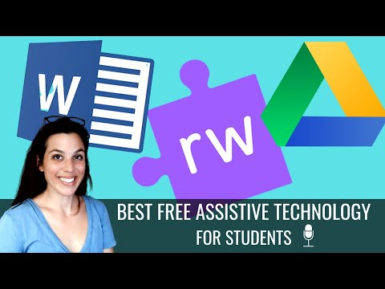

Steps towards a reasonable adjustment plan (RAP)

Step 1 
Evidence: you will need specialist teacher, educational psychologist or medical evidence to identify your disability and provide written evidence.

Step 2 
Send your evidence to disability@metanoia.ac.uk

Step 3

Metanoia Institute’s Disability Officer will read the report and make a draft reasonable adjustment plan (RAP). They will also get in touch with you for your input, comments and feedback.

Step 4 
Once agreed, and your consent has been given to share the RAP, it will be circulated to your Director of Studies, Academic Coordinator and Primary tutor. The RAP will then be implemented to support your studies and learning journey.

